Downloading and Importing HRS Files into Stata
For many HRS users, downloading and importing the HRS data into their preferred statistical software is the first step of analysis. While the HRS provides raw data files (e.g., h14da.zip) and program statement files (e.g., h14sas.zip) to read in data with a specific software, how to appropriately use these files to import raw data can be challenging. Below is a step-by-step guide on how to import and save HRS data using Stata statistical software and code.
Step 1 – Register as an HRS user.
- In order to access the public release data, users must first register with the HRS.
Step 2 – Log in, proceed to the Data Downloads page, and select the data you wish to download.
- There are many data products to choose from, and some files are already available in Stata format (e.g., the RAND Contributed Files). The “Biennial Data Products”, including the core interviews, exit interviews, and off-year studies, are only available as .DA files and require the program statements to import into Stata.
- For this example, we’ll use the 2014 HRS Core (Final) (v.2.0) data highlighted in the screenshot below:

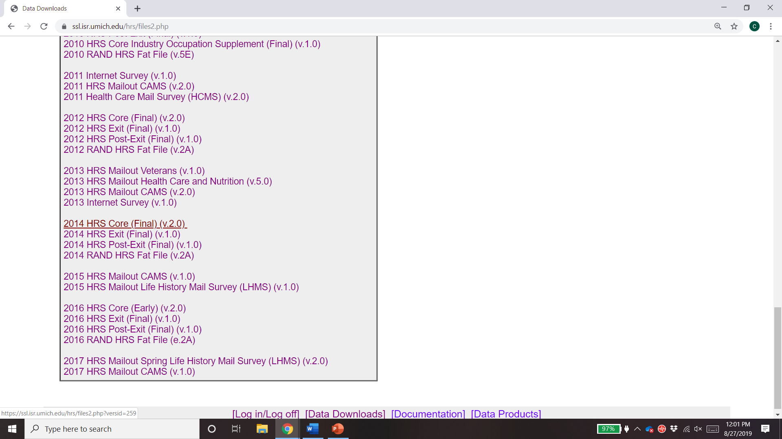
Step 3 – Download the data and program statement files.
- In order to import the data into Stata format, we’ll need to download both the “Data files” (i.e., h14da.zip) and “Stata program statement files” (i.e., h14sta.zip) zip files.
- For your analysis, you may also wish to download the “Data Description” and “Codebook files”. Both files are helpful to have on hand when coding the HRS data.

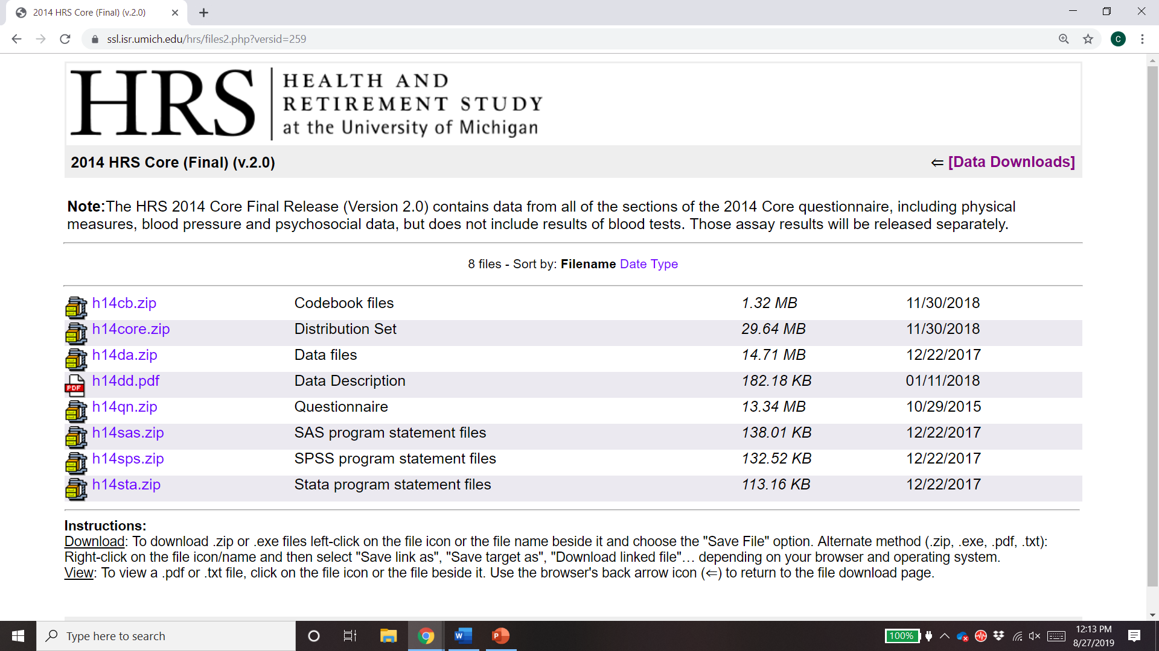
Step 4 – Extract and save files into a shared file location.
- After downloading the data and program statement files, we will then extract the data into a shared file location. This is easily done by selecting the “Extract All” button on the file explorer’s task ribbon, selecting the appropriate file location using the “Browse” button, and selecting “Extract”.
- To ease the process of importing the data, saving the data and program statement files in the same file location is advised. In this example, we’ve saved the files in a folder on our desktop titled “HRS 2014”.

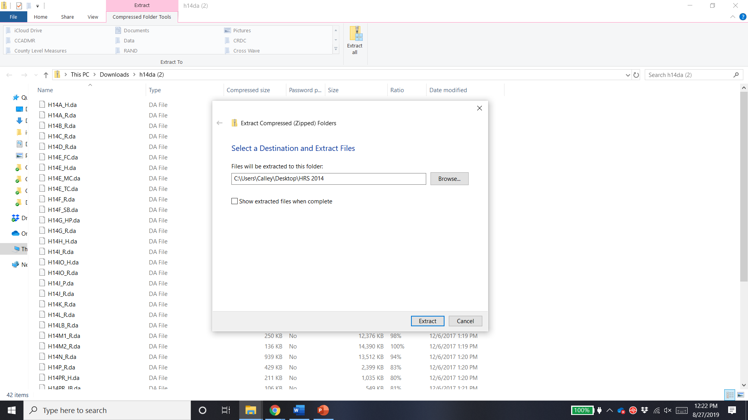
1.
2.
3.

Step 5 – Finally, open Stata and an accompanying do file. Use the infile command to import HRS data into Stata using the .DA and .DCT file names.
- Using the file pathways where the extracted files are saved, as well as the names of the .DA and .DCT files, we execute the Stata code in the screenshot below to read in the raw data files.
- This Stata code imports the HRS data using the infile command (line 5) and saves the HRS data in Stata format using the save, replace commands (line 6).
- Multiple HRS files can be imported at once using the foreach command (line 12). In this example, the data sets titled H14A_R, H14B_R, and H14C_R, are all being imported and saved using the same lines of code (e.g., infile and save, replace, on lines 14-15).
- To translate this code to your own computer, you’ll need to update the file pathway to indicate where your .DA and .DCT files are saved (line 4 or 13). You can also edit the .DCT, .DA, and .DTA file names (lines 5-6 or 12) to reflect the HRS data set you want to import.

A few other notes about downloading and importing HRS files:
- Remember, you’ll need both the .DA and .DCT files saved in the same location in order for the infile command in the screenshot to work. If the files are saved in different locations, you will need to edit the file pathways in your Stata do file to reflect this decision. Once in Stata format, you can save your data in any location you choose.
- If you choose to use a different software (e.g., SAS, SPSS), you can export your data from Stata into a .CSV file or SAS XPORT file. You can also use the program statements provided by the HRS to directly import into SAS or SPSS.
- You can also use the infile command provided in the .DO file from the HRS (this file is included in the program statement files). If you decide to do so, you’ll need to edit the file pathway in the corresponding .DCT file to match where the .DA and .DCT files are saved on your computer.

