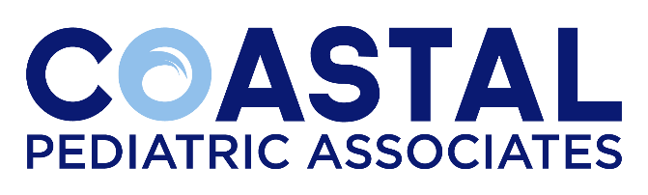
Dear Student:
We are happy that you have chosen our practice for your clinical experience. Our practice provides many clinical opportunities for students from high school through medical school, including observation, internships, externships and clinical rotations.
Coastal Pediatric Associates is locally owned and operated with locations in West Ashley, Summerville, James Island and Mt. Pleasant. All our physicians are board certified in pediatrics and provide a full range of pediatric services including well child checks, sick visits, treatment for ADHD, dermatology, sports physicals, care of premature infants and medically fragile children. At Coastal Pediatric Associates, we believe that our purpose is to nurture and champion the health of all children and their families. Our core values are to act as compassionate, relentless advocates for every patient and family.
Prior to beginning your experience with us, we will need a completed application.
Upon your 1st day in clinic, you will meet the practice manager and your assigned preceptor, if appliable.
For questions related to arrival times contact the office manager at your assigned office.
We trust your experience with us will be a pleasant one. Don’t hesitate to contact our human resources office at 843-737-9499 or by email at hr@cpakids.com if you have any questions.

Sincerely,
Carol Murray
Coastal Pediatric Associates
Human Resources

