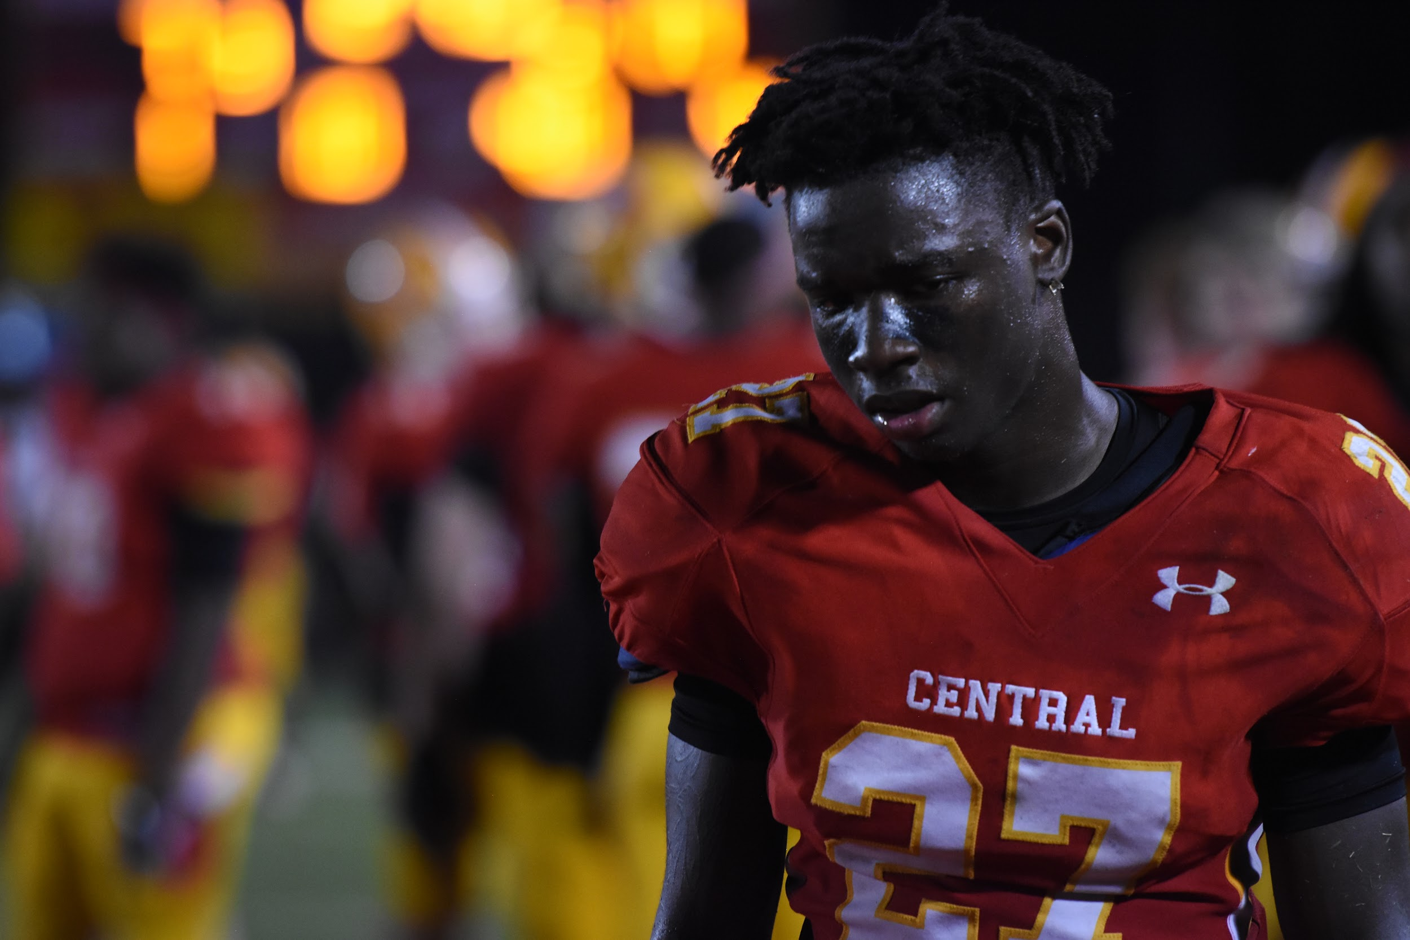
Clarke Central High School senior cornerback Edwin Summerour stands on the CCHS football field during the fourth quarter of CCHS’ varsity football game against Cedar Shoals High School on Sept. 28. CCHS lost against CSHS for the first time in ten years, ending with a score of 17-7. “We played a good game. (In) my opinion, last night defense played really well. (The referees were) terrible. It’s hard to win a classic city championship when you have to beat (CSHS) and the (referees),” Summerour said. “Going into the second half, they just (started) calling everything one-sided, so it was just funny to me because I’m like, they must really want (CSHS) to win and beat this (10) game streak.” Photo by Kelly Fulford

