LinPosBl

*AMENDMENT NO.1 TO SOLICITATION*

TO: ALL VENDORS

FROM: Kevin Sanders, Procurement Manager

SUBJECT: SOLICITATION NUMBER: USC-FPB-2719-KS

Psychiatrist and a Nurse Practitioner or Physician Assistant through a Locum Tenen service.

DATE: November 18th, 2014

This Amendment No.1 modifies the Request for quote only in the manner and to the extent as stated herein.

Vendor questions and answers

BIDDER SHALL ACKNOWLEDGE RECEIPT OF AMENDMENT NO.1 IN THE SPACE PROVIDED BELOW AND RETURN IT WITH THEIR BID RESPONSE. FAILURE TO DO SO MAY SUBJECT BID TO REJECTION.

_____________________________ ________________________

Authorized Signature Name of Offeror

_____________________________

Date

**Vendor A**

What are the payment terms? (ex…30 days from date of invoice)

Payment Terms are Net 30 (after acceptance)

What is the annual budget for this contract?

$100,000

Can the Psychiatrists be Board Eligible?

No, Board Certified

Do you need the Nurse Practitioner/Physician Assistant to have Psychiatric experience?

No, they can be General Medicine, Family Practice, etc…

Is an all-inclusive rate required? (ex…The hourly rate to include travel and lodging expenses)

Rate is all inclusive

Will there be a negotiation period for terms/conditions if our proposal is accepted?

No negotiation will be done with this procurement

Will any language changes be allowed? (ex..tax language, indemnification)

No

If we can’t agree on language, terms/conditions, can we withdraw our proposal without penalty?

In order to be awarded a contract under this solitation, all terms and conditions must be agreed to by Bidder. Failure to comply with any of the terms and or conditions will result in no award for the Bidder.

What type of facilities will they be working in?

Ambulatory <http://www.sa.sc.edu/shs/>

Will they be working at more than one location?

No

How many hours a week are the locum tenen services needed?

20-40

Regarding the price. When it shows a max price…is that the most you will pay per hour for those services? (ex…Psychiatrists is $253.01/hr and NP/PA is $68.82/hr)

Yes, the prices shown are the maximum acceptable prices per hour for each item. Offeror must elect to provide pricing either at or below the maximum prices.

**Vendor B**

When will the new 100,000 sq. foot Student Health Center be built, furnished and open?

Construction has not begun yet.  I would guesstimate 12/2016 at this time.

*“Psychiatrist responds to emergencies*” – does this require On-Call duties?  If so, please detail the expectations and if this also qualifies for compensation.

There are no true “on-call” duties in the traditional sense.  For example, in rare occasions, an emergency (i.e. hospitalization of a student) may begin at 4:15pm and coordination of psychiatric services may be needed after 5:00pm.  Compensation would be at an hourly rate.

*“Work Tuesdays and Fridays”* – what is the reason for this? and what flexibility is there?

Tuesdays and Fridays are the days we do not have adequate staffing for the volume of patients we see.  There may be some flexibility if our regular staff is out of the office or if the volume of patients increase on other days of the week.

Are there any Incumbents?

Yes.

What is the reason for bid?  Are these new roles?

Two reasons: 1). We have an open position and need coverage while we are searching for a full-time psychiatrist. 2). One of our psychiatrists has reduced her hours.

*“Must be willing to work at least 3 Sundays a month from 2-8pm and two days a week from 1-6 pm. Other hours are negotiable.”* – what are the typical days and times available for the provider to work?

The hours stated above.

What type of Electronic Medical Record system do you use?

Point and Click

What is the Medical Hierarchy of the Student Health Center?  (i.e. Director and flow chart of medical decisions/authority for all specialties within the Health Center)

Executive Director -→ Medical Director → Psychiatrist →  Peer Review Board

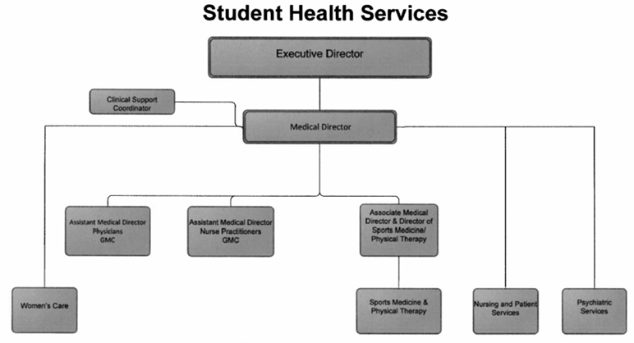

If we decrease the price of the Psychiatrist, can we increase the price of NP/PA to supersede the Maximum rate?

Maximum rates for each position are set. You are welcome to offer a lower hourly rate, but any rate in excess of the stated maximum will not be awarded

What is the reasoning behind the schedule requests for both Psych and NP/PA?  *(The requested schedule seems a bit untraditional and can cause a greater challenge identifying quality candidates to accommodate a workload less than 40 hours/week and unique shift times.  We just want to understand to better educate our future providers)*

Psych - As stated above, Tuesdays and Fridays are the days we do not have adequate staffing for the volume of patients we see. NP/PA – If a mental health provider, the hours would be as stated above.  If a general practitioner, the hours would depend on the need for services.