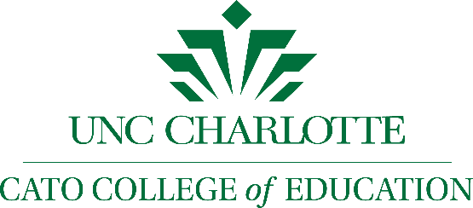
Education Learning Community
9201 University City Boulevard
Charlotte, NC 28223-0001

Education Learning Community Mentor Agreement

I acknowledge that, as a mentor for the Education Learning Community (ELC), I am accountable to our members and to the community we serve. I understand that as an ELC mentor, I have a responsibility to ensure that the organization does the best work possible in pursuit of its goals. I believe in the purpose and mission of the ELC, and I will act responsibly and prudently as its steward.
As part of my responsibilities as an ELC mentor I commit to the following:
- I will serve as a positive mentor to students within the Education Learning Community at all times.

- I will represent the ELC and Cato College of Education in a positive light through my actions and choices both in-person and on social media.
- I will report any concern to the Education Learning Community Coordinator if it may negatively affect the academic or social well-being of other students or my own performance as an ELC member.

- I will work respectfully and in good faith with ELC members and staff as partners toward the achievement of our goals.

- I will actively participate in all ELC mentor meetings and activities.

- I will make a formal point of contact with my mentee(s) at least 1 time a month and an informal connection at least 2 times a month.

- I will champion the organization’s work and the work of its members and I will positively represent the ELC in all respects.

_______________________________ ______________________________
ELC Mentor Signature and Date ELC Coordinator Signature and Date

GOOGLE DOC: https://docs.google.com/document/d/15m0uDjxodLnIk73BV9I9Pl39eJLojFzzrV8fRmzbMFA/edit

