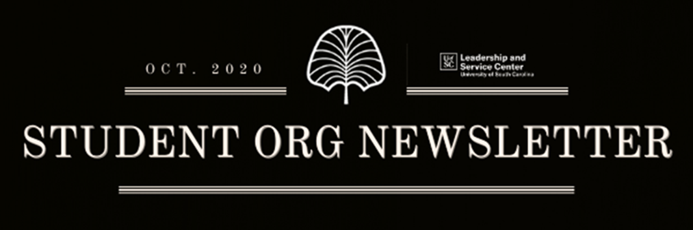

Hello Student Organization Leaders!

Happy October! We are going to begin sending out monthly email newsletters with events and resources for Student Orgs. Please see below for this month’s news and announcements and reach out if you have any questions.

**Student Organization Roundtables**

This month’s Student Organization Roundtable will be Wednesday, October 21 from 3-4 pm. The topic will be “Avoiding Burnout as a Student Leader.” Register for the Roundtable on Garnet Gate or by using this [link](https://garnetgate.sa.sc.edu/event/6498146).

**Free Speech Events**

Join the Leadership and Service Center and the Civic Leadership Education Action Team for “My Words Shape Your World: How to Navigate Free Speech on Campus” on Thursday, October 8 from 6-7 pm. Dr. Kirk Randazzo will join us to answer student questions about free speech on campus and how students can navigate the nuances of this topic. Click [here](https://garnetgate.sa.sc.edu/event/6501748) to register on Garnet Gate.

The Leadership and Service Center and Office of Multicultural Affairs are hosting an event on Thursday, October 15 from 12-1 pm called “Freedom of Speech and the First Amendment: When Hate Speech Offends.” This session will focus on responding to free speech, hate speech and the First Amendment challenges. We will discuss First Amendment protection with bias related incidents, protests and demonstrations on campus and within our society. Click [here](https://garnetgate.sa.sc.edu/event/6501742) to register on Garnet Gate.

**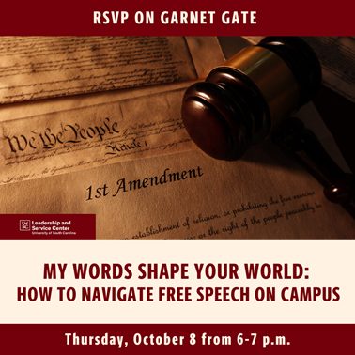  **

**No Title Needed**

Have an outstanding member in your organization? No Title Needed in an initiative to highlight students across campus demonstrating leadership without a title or position. Use this [link](https://www.sc.edu/about/offices_and_divisions/leadership_and_service_center/leadership_development/no_title_needed.php) to nominate someone in your organization! Selected students will be featured on the Leadership and Service Center’s social media and receive prizes!

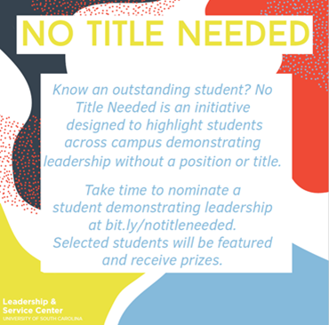

**Student Org Funding Requests**

Student organizations may [request funding](https://sc.edu/about/offices_and_divisions/leadership_and_service_center/documents/treasurer_handbook_2020l.pdf) for programming, conferences, competitions, and tournaments using the Garnet Gate budget request.  Organizations are encouraged to work with their [Comptrollers](https://1drv.ms/x/s!AqN5Vo5iWJ6Agaw7bdI2nSSn1Jyf0g) as a resource throughout the allocation process.  We know you have great ideas for engagement within your organizations – let’s make those a reality!

**Garnet Gate Roster Updates**

Verified records of student organization memberships are collected in each student’s [**My U*of*SC Experience**](https://sc.edu/about/offices_and_divisions/advising/advisor_toolbox/advising_technology_access/myuofsc_experience/index.php#:~:text=What%20is%20My%20UofSC%20Experience,that%20complements%20their%20major%20curriculum.&text=Every%20undergraduate%20student%20will%20have,accessible%20by%20their%20Academic%20Advisor.), a university platform which records the many experiences both for credit and not for credit that students engage in while at UofSC.

In order for your organization members to have their involvement included in **My U*ofSC* Experience**, it is your responsibility as an organization to verify your roster is up to date for Fall 2020 and that it reflects your active membership. The accuracy and integrity of these student records is essential. Only records of membership that have been verified will be collected in **My U*of*SC Experience**.

Click [here](https://www.loom.com/share/cfb172079fcf4db7953371a57cf8f647) for a video showing how to complete this process through the manage portal in Garnet Gate.

Should you have additional questions, don’t hesitate to reach out to us at [lsc@sc.edu](mailto:lsc@sc.edu)!

**Student Organization Resources**

Looking for resources on how to lead your organization? Head over to the LSC’s website to view the [Organization Toolbox](https://www.sc.edu/about/offices_and_divisions/leadership_and_service_center/student_organizations/organization_toolbox/index.php) to get resources on marketing, communication, event planning and more!