How to Self-Enroll in the UCV Sample Course
- Log into Blackboard.

- Click on the Courses link in the left menu.
- Click on the Course Catalog link in the top right.
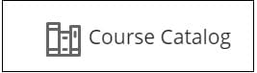
- Use the search field to search for the course name (UCV Sample Course Content), and then click on the Go button.
- Hoover of the name (UCV-SAMPLE-COURSE-CONTENT) in the COURSE ID column and click on the down arrow that appears.

- Click Enroll.

