CHAPTER 1
Introduction
In August 2006, then-White House Press Secretary Tony Snow revealed that President George W. Bush had been reading Albert Camus’ famous novel, The Stranger, while vacationing at his ranch in Crawford, Texas. When asked to comment, Snow said that President Bush “found it an interesting book and a quick read” and that he and the President had discussed its meaning. “I don’t want to go too deep into it,” Snow explained, “but we discussed the origins of existentialism” (Dickerson 2006).
Satirists seized upon the otherwise trivial news item for its offerings of political humor. Lee Siegel blended Bush’s no-nonsense rhetoric with the terse ‘American’ style Camus used to fashion the memorable voice of Meursault, fusing the two figures together in his New Republic article entitled “Strangerer” (Siegel 2006), while writers with more of a political axe to grind reveled in the ironic contrast between Bush’s and Camus’ positions on just about everything, from religious faith to the use of military force to capital punishment. One might be surprised that sharper contrasts were not drawn between the President who dubbed himself ‘the decider’ and Camus’ Meursault, who decides next to nothing. The closest anyone came to making such a comparison was apparently in the vague suggestion floating around the Press Room that the President was going through an ‘existential’ foreign-policy crisis. Tony Snow reportedly (and somewhat tastelessly) rebuffed this suggestion by insisting that “he [the President] doesn’t feel like an existentialist trapped in Algeria during the unpleasantness” (Dowd 2006).
A few writers who were familiar with Camus’ work understood that the greatest irony of all was the discomfiting parallel between the racial and colonial violence between the lines of The Stranger and America’s questionable and controversial war in Iraq. While not all were familiar with Conor Cruise O’Brien’s or Edward Said’s scathing critiques of Camus’ colonialism, John Dickerson understood that Bush’s taking-up of the novel was ripe for “geopolitical literary misinterpretation” (2006). Half-sarcastically concerned that a Camus-Bush connection would be misunderstood in the Middle East and around the world, Dickerson proclaimed it to be “the first time that national security demand[ed] an official version of literary criticism” (2006).
Putting aside concerns about national security and international perception for a moment, it is curious that this otherwise insignificant Presidential tidbit aroused so much fascination. The rest of the President’s summer reading list, which reportedly included a study of Robert Oppenheimer and a biography of Abraham Lincoln (meaning the President was reading about absurdity, atomic weapons, and a divided nation all at once), made less of a media splash (Gopnik 2006). A few critics were offended by what they saw as a misguided attempt by the White House to bolster Bush’s image as an intellectual, but I think the fascination that the story sparked within the country was profound and enlightening in terms of people’s interest in the more mundane facets of the president’s personal life instead of his actual efforts on the geopolitical front.
CHAPTER 2
A Brief History of the Philosophy of the Absurd
Our present confusion about the absurd results not only from a lack of attention to Camus’ theoretical contribution, to which all but one of the following chapters of this work are addressed, but from the many competing philosophical understandings of absurdity, which I review here. In ordinary language, we use the word ‘absurd’ interchangeably with ‘incongruent’, ‘irrational’, ‘senseless’, and ‘ridiculous’, but these synonyms stand in an unclear and uncomfortable relation to the philosophical meanings of the term. In fact, in standard dictionaries, ‘absurd’ is often given two or more separate meanings. The first is generally that which is “utterly or obviously senseless, illogical, or untrue… laughably foolish or false,” while the second is “the quality or condition of existing in a meaningless or irrational world” (Random House Webster’s College Dictionary 1991). This humorous double-sense of ‘absurd’ suggests that even the word may be charged with a kind of ambivalence, a tension between comedy and tragedy, laughter and despair (Figure 2.1).
The word ‘absurd’ is actually derived from the Latin absurdus, which means “out of harmony,” what is unharmonious to the ear (see Esslin 2001, 23), but its likely root is not surd, meaning ‘deaf’, but svar, meaning ‘tune’ or ‘sound’ (Halsey 1882, 151). While this chapter refers to Camus’ work, its goal is to briefly treat other absurd theorists in order to highlight key themes and debates within the development of absurd thought and to give the reader a sense of the various interpretations of absurdity, which are perhaps as
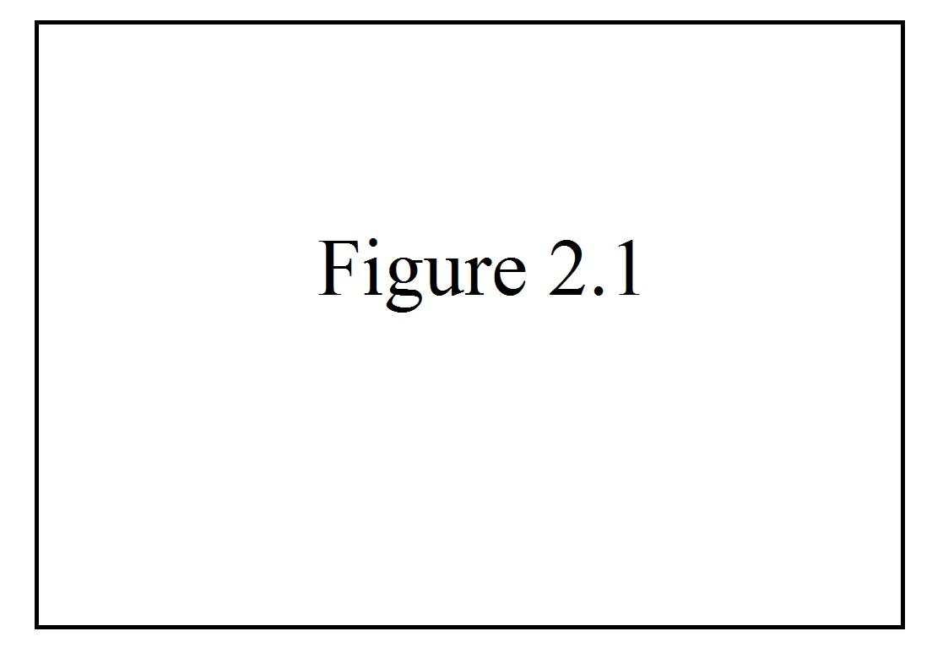
Figure 2.1 Type the caption of your figure here. Refer to the Formatting Guide for specific instructions regarding tables and figures.

discordant as the etymology of the term implies. Because the absurd remains such a muddled concept, attempts to trace its heritage have had only the most limited success. To give but one example, John Cruickshank sees in Camus’ absurd “a contemporary manifestation of a scepticism as old at least as the Book of Ecclesiastes” (Cruickshank 1960, 44). But Cruickshank’s equation of both Ecclesiastes and absurdity with skepticism seems strangely shortsighted for such a thoughtful critic. Most studies have focused, instead, on the absurdity inherent in Qohelet’s key word, hebel, translated often as ‘vanity’, but which literally denotes ‘breath’, ‘breeze’, or ‘vapor’ (see Fox 1989, 29; Fredericks 1993, 12n; Dor-Shav 2004; Berger 2001). These studies have argued that the sense of the term, and of that key phrase which so often follows it, reut-ruah, or ‘chasing after wind’ (Jastrow 1919, 204n), are not far from the contemporary notion of absurdity. Unfortunately, very few of these studies have been clear about what that contemporary notion of absurdity entails.
2.1 SUB-SECTION
Michael Fox’s study of Ecclesiastes specifically unites Qohelet’s words with Camus’ absurd philosophy and makes a detailed argument for the relationship between the two. “The best translation-equivalent for hebel in Qohelet’s usage,” says Fox, “is ‘absurdity’, understood in a sense and with connotations close to those given the concept in Albert Camus’s classic description of the absurd, The Myth of Sisyphus” (1989, 31).
2.2 SUB-SECTION
What is lacking in Fox’s account of this relationship, however, is a thorough examination of the concept of the absurd, itself.

