Ireland McCage
Webmaster
Clarke Central High School, ODYSSEY Media Group
Top Review
Word count: 521

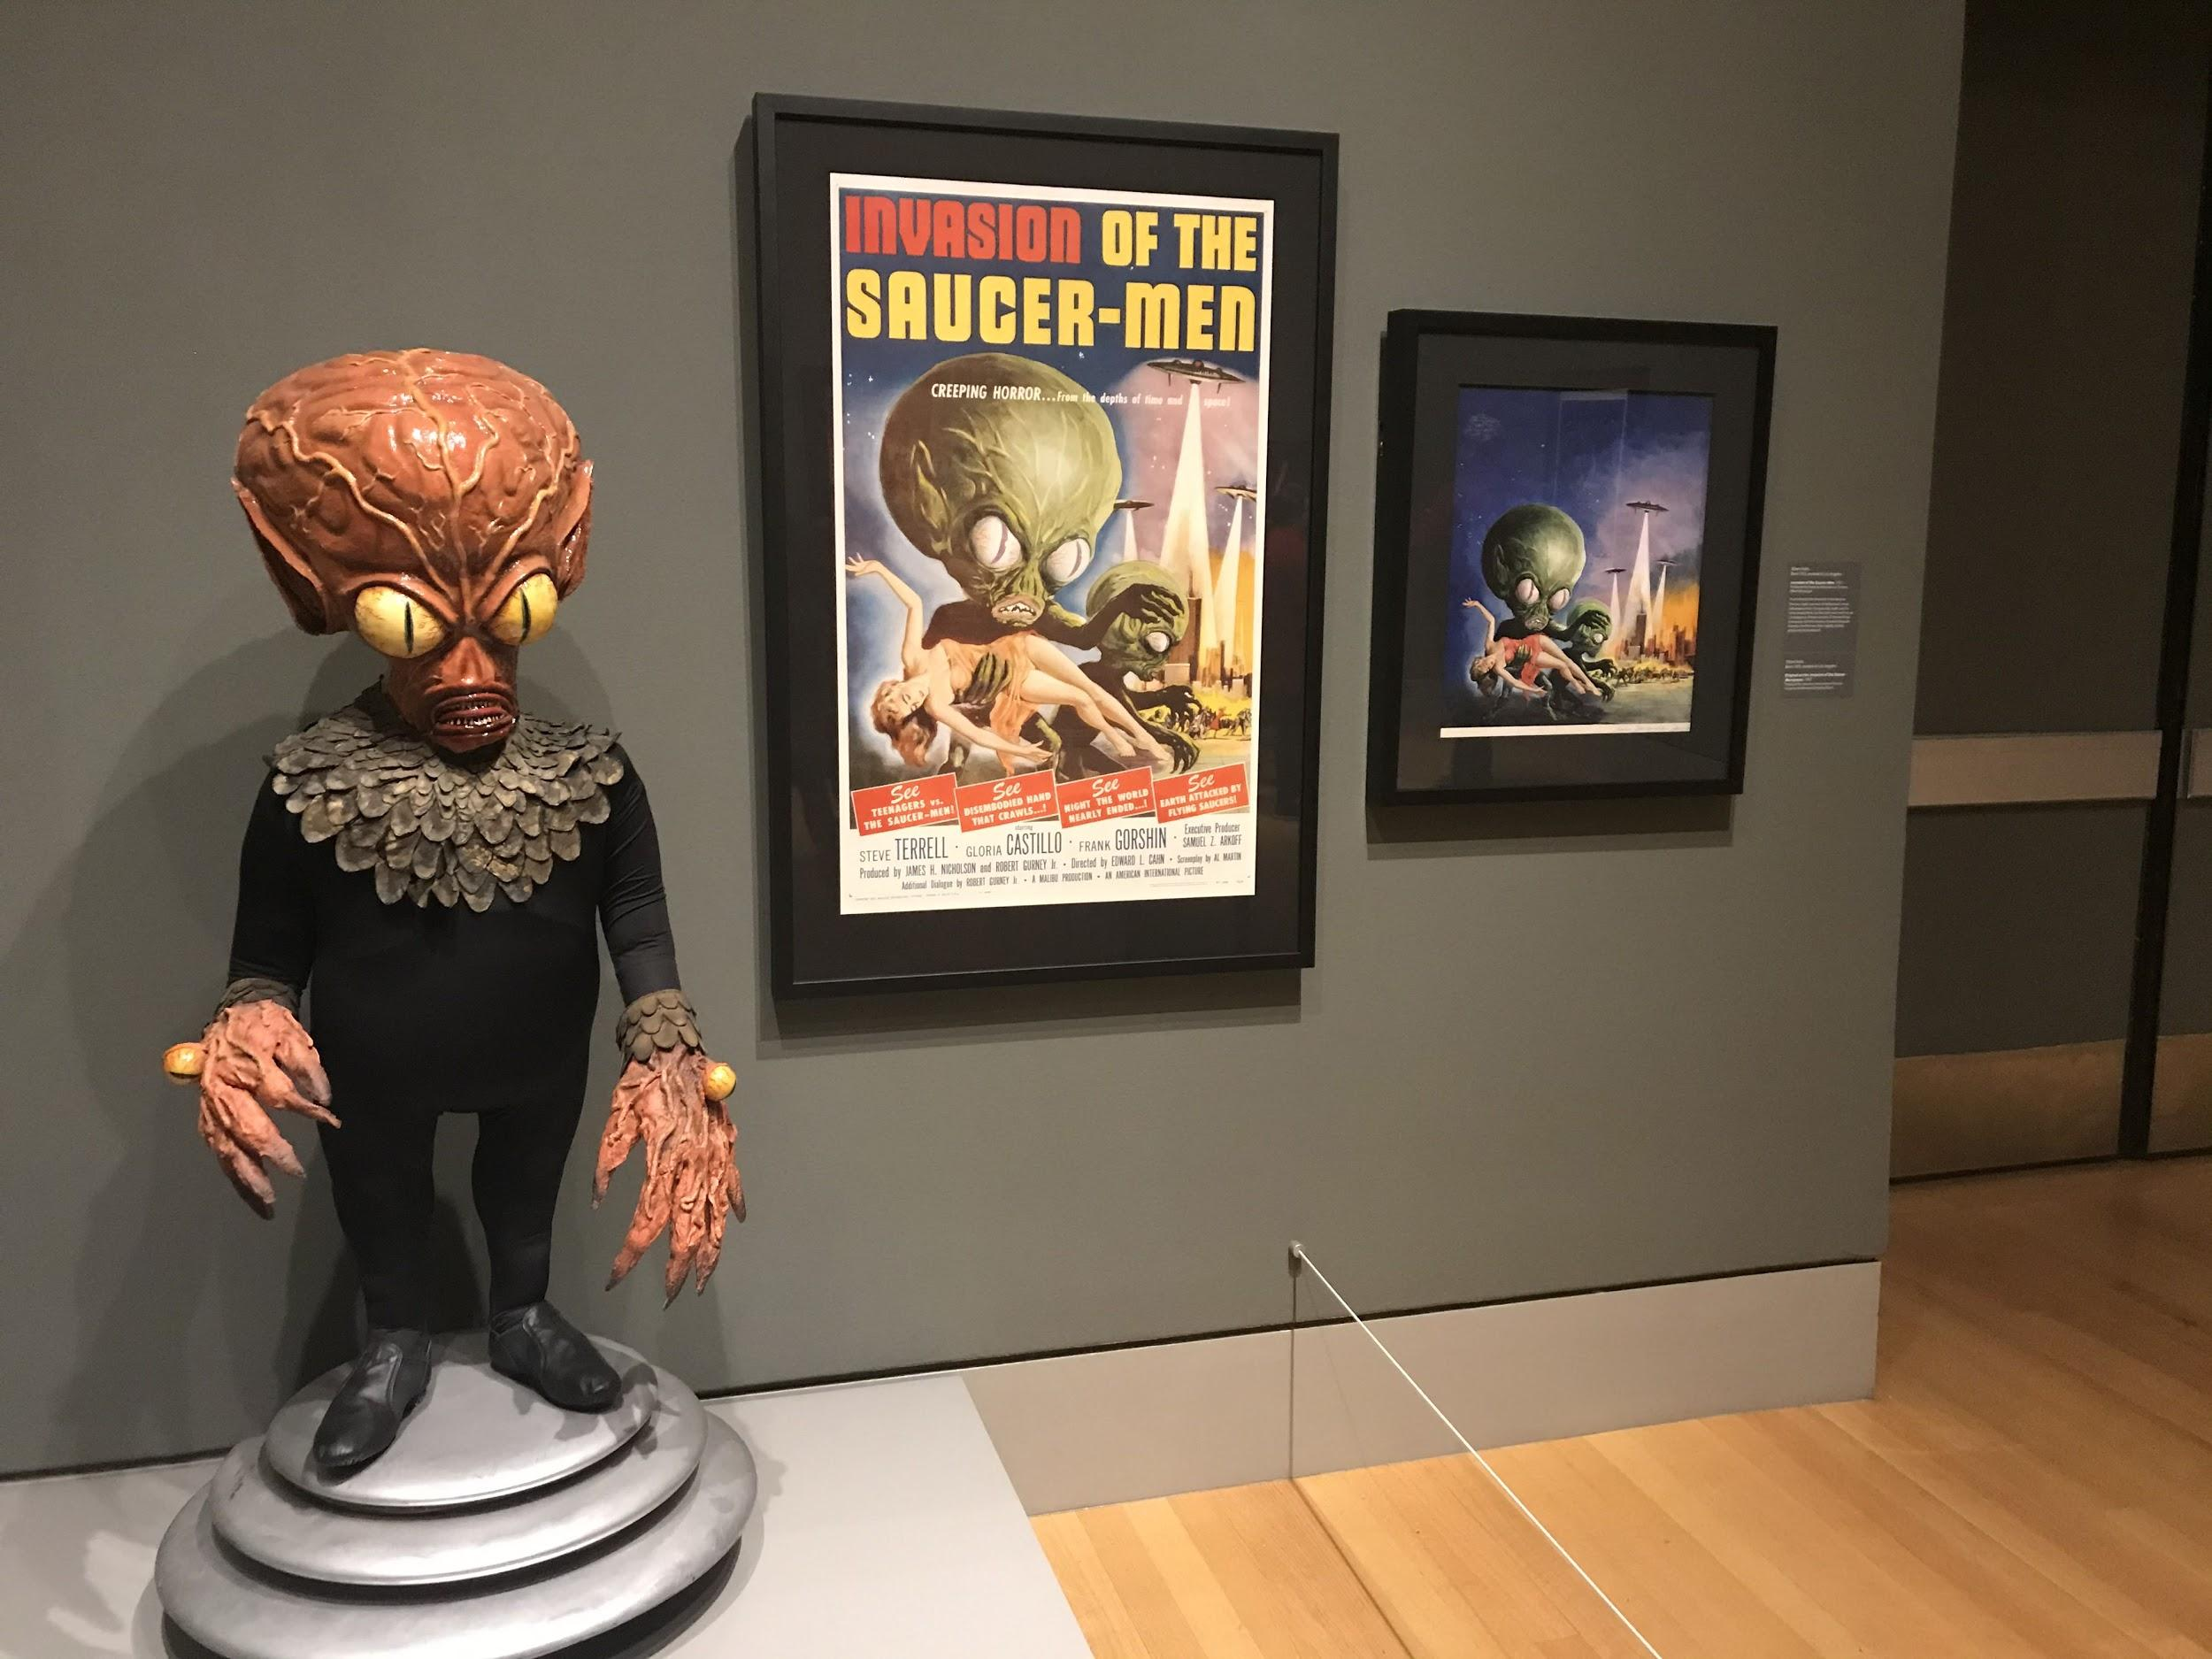
Above: A statue of an alien from the movie “Invasion of the Saucer Men” stands next to posters for the same movie. “Invasion of the Saucer Men” was released in 1957 and perfectly fits the overall theme of the sci-fi and horror exhibit it is featured in. Photo by Ireland McCage

On Feb. 15, the Columbia Museum of Art opened the “It’s Alive! Classic Horror and Sci-Fi Art from the Kirk Hammett Collection”.
For those who are fans of art or horror movies, the Columbia Museum of Art will be hosting the “It’s Alive! Classic Horror and Sci-Fi Art from the Kirk Hammett Collection” from Feb. 15 to May 17.
The exhibit mainly features movie posters from old sci-fi and horror movies, but it also contains paraphernalia based off of those films, like games and statues.
When the viewer walks in, they will be immediately hit with the cover art for the collection: a bright red zombie hand shooting out from the dirt. This entrance makes a grand statement and helps to set the tone for the rest of the pieces.
As people move throughout the collection, they will get a chance to view movie posters from all over the 1900s. The earliest poster featured is the 1921 “Hamlet,” while the latest is the 1979 “Alien.”
This wide variety also includes a mix of well-known films, such as “Frankenstein” and “Dracula,” and relatively unknown movies like “Murders in the Rue Morgue” and “Mystery of the Wax Museum.”
All of the posters are accompanied by a small plaque that lists the title of the movie, the director and what year the movie came out.
Only plaques for popular movies, however, have additional information on topics such as the inspiration for the film or techniques that were used. If someone came to the exhibit hoping to find out more about the smaller films, they would be greatly disappointed.

If the viewer dares to venture out of the exhibit and walk down a small hallway, they will find a small salon where the horror continues.
In an effort to bring a modern touch to the typically old-fashioned museum, a red light has been installed on the floor in front of a “Frankenstein” poster so that viewers can take a scary selfie. This photo opportunity allows for a variety of fun poses and will be a great memory to have long after the collection has moved on.
The entire collection takes up 4 rooms with posters covering what feels like every inch of the wall. With so many pieces to look at, the ticket price of $10 for adults and $5 for students is well worth it.
While most of the exhibit flows wonderfully from one piece to the next, viewers will be shocked when they notice the “Alien” and “Star Wars” posters hanging in the corner. Though these two films do hold significance in the sci-fi world, their modern styles detract from the early 1900s feel of the other posters.
Some of the creatures featured in the posters may be frightening to young children. However, the collection is perfect for people who grew up watching these movies, or adults who enjoy watching these types of films now.
From the posters on the wall, to the alien standing in the corner, to the cut-out of King Kong, this exhibit is steeped in a genuine love for the genres of horror and sci-fi.
If you are an avid classic horror movie fan, or even just have a passing interest in it, this collection is definitely a must see.
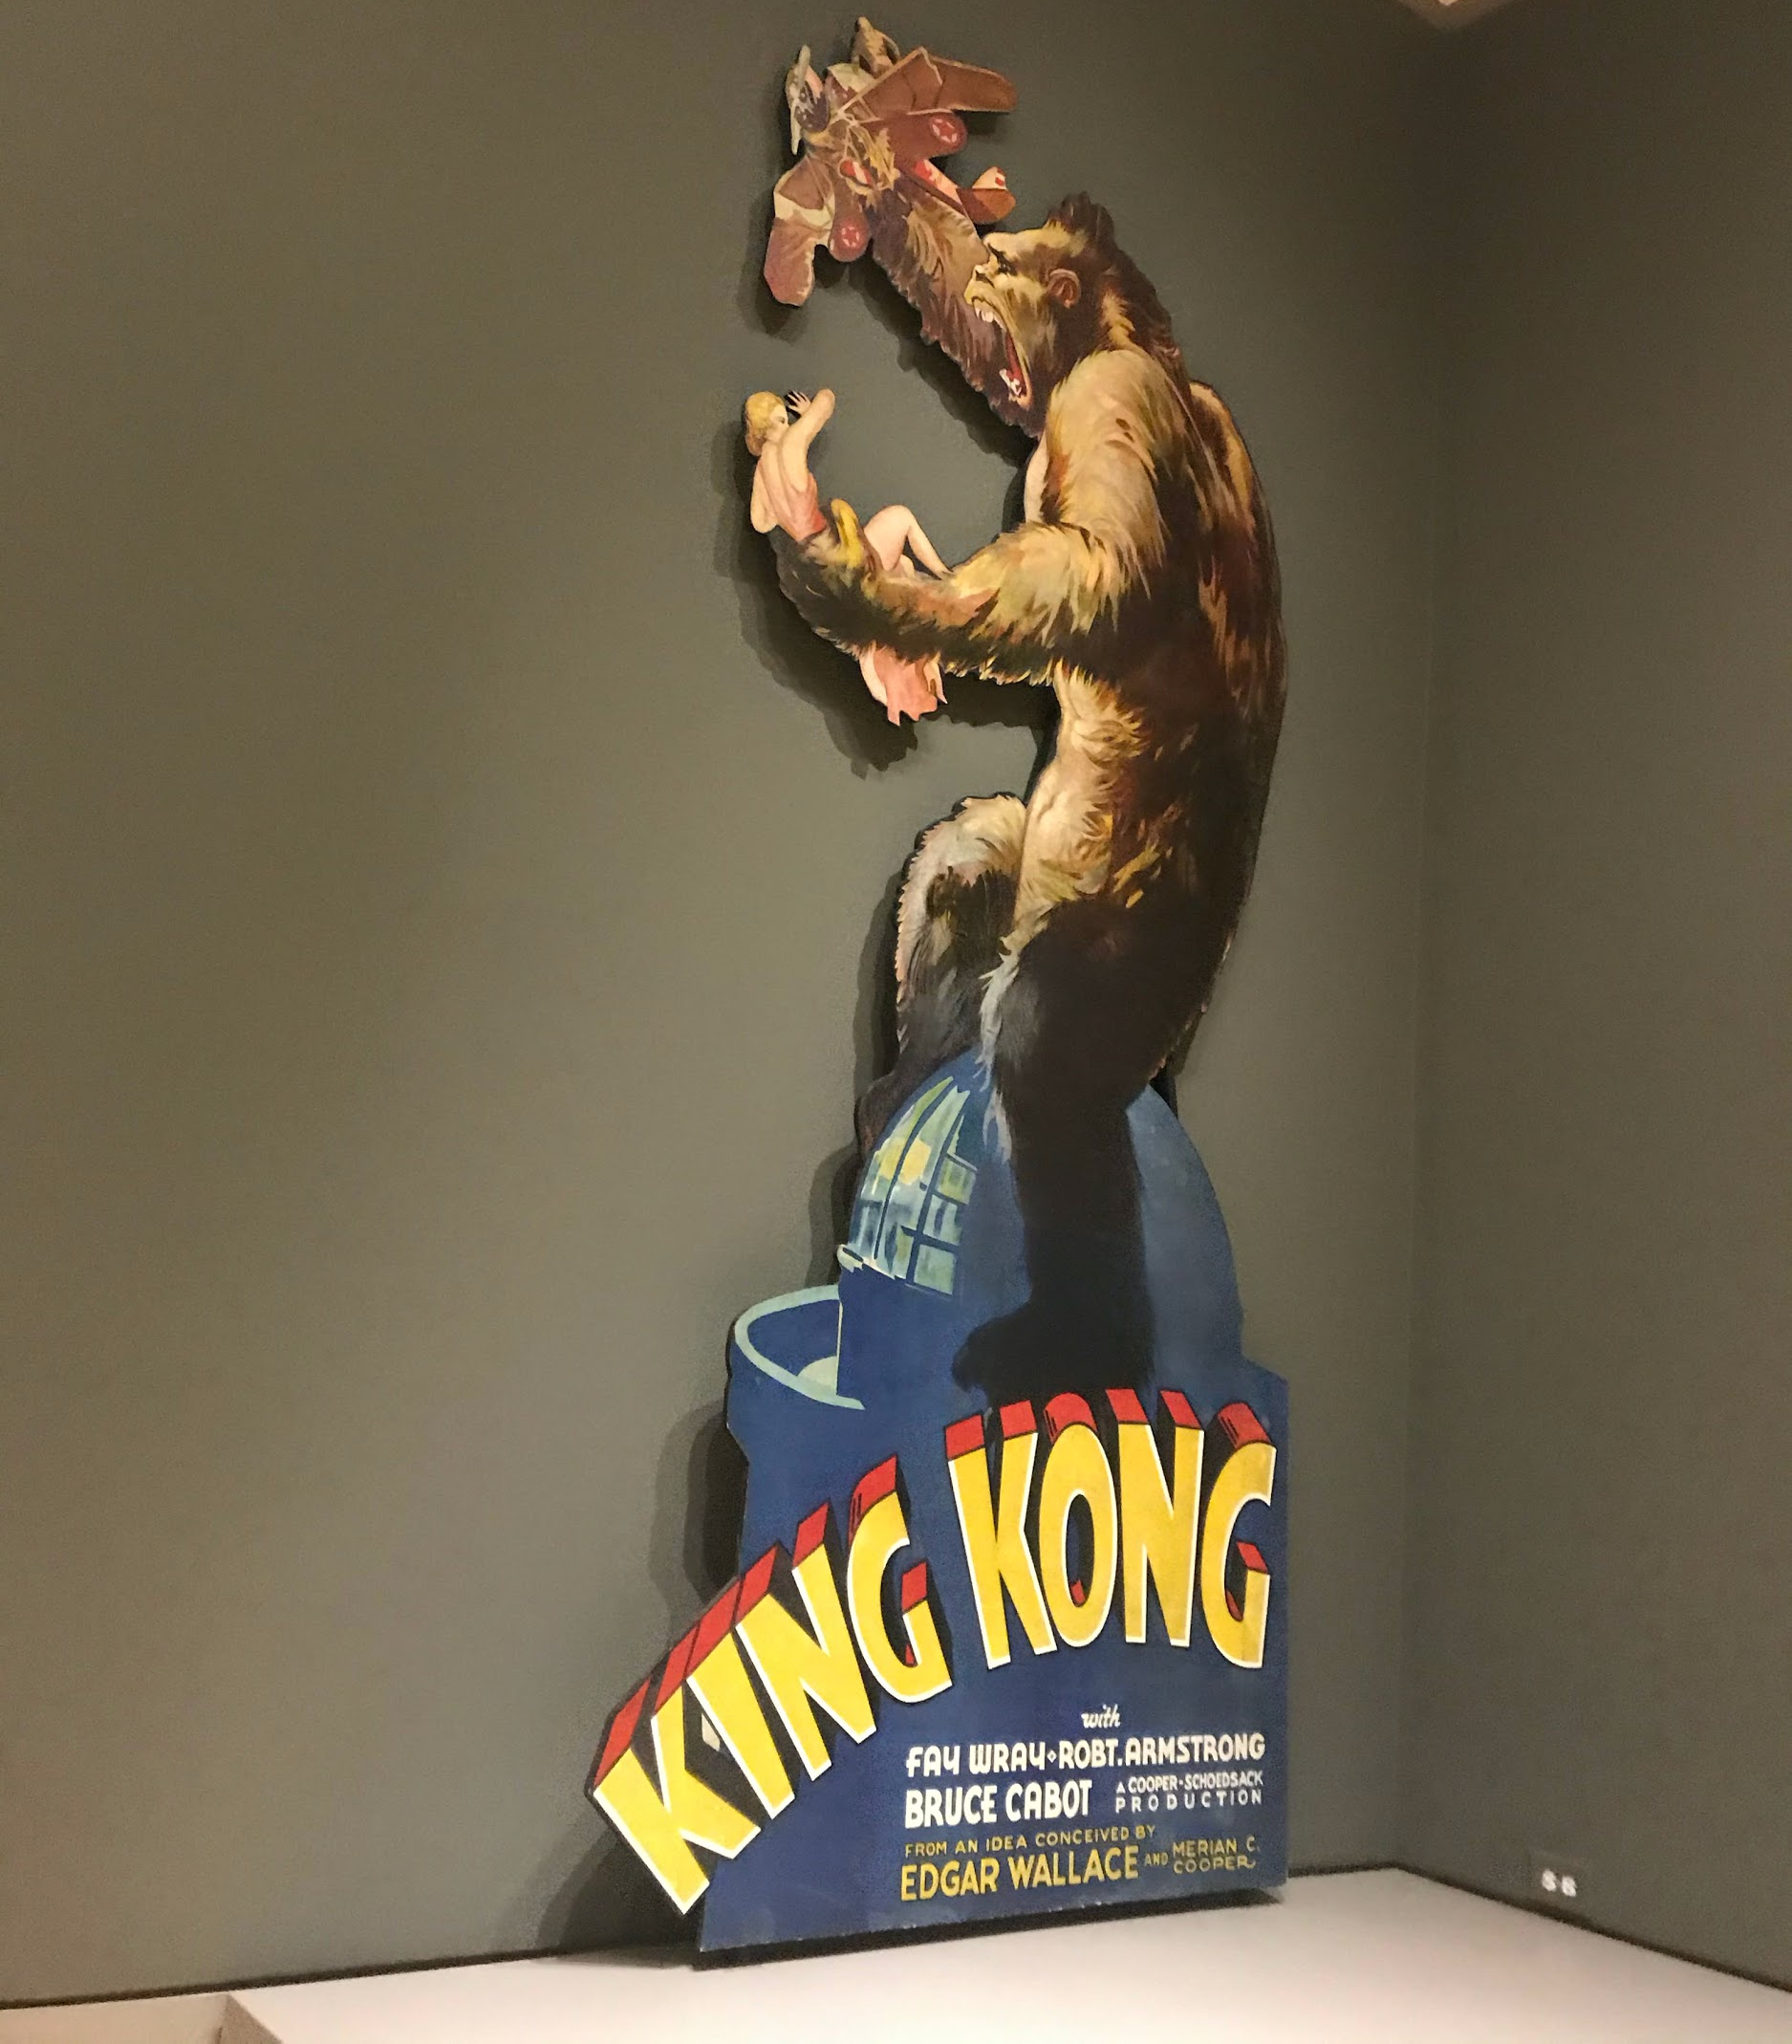
Above: A cut-out of King Kong holding a woman and a plane is propped against the wall. The original King Kong movie was released in 1933 and quickly became a cult classic. Photo by Ireland McCage

