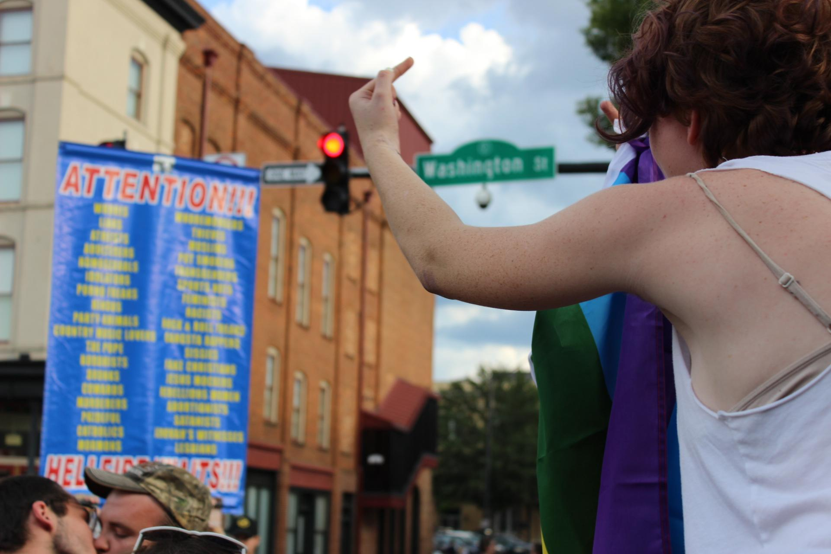
Above: DRIVING OUT THE DARKNESS: The 20th annual Athens PRIDE Street Festival took place on West Washington Street on Sept. 9. A few hours into the festival, a protester arrived holding a sign listing groups of people for whom “hellfire awaits,” including “homosexuals,” “atheists” and “rebellious women,” and a crowd quickly formed to peacefully counter-protest. Clarke Middle School eighth-grader Penelope Anderson (shown on right) found the counter-protesters inspirational and decided to join them to support their message. “I thought that all of the people speaking out against (the protesters) and standing up for the community were all really brave. My first reaction was just, ‘Yeah, I definitely want to be a part of this,’” Anderson said. “I found comfort in all those people. I found a home, kind of safe space in them.” Photo by Roxanne Domizi

