Hello Student Organization Leaders!
Below is the Student Organization Newsletter for the month of December. Please reach out to us at lsc@sc.edu or 803-777-7130 if you have any questions or if there is anything that you need.

Spring Student Org Fair
Mark your calendars for the Spring Student Organization Tour, which will take place on Jan. 20, 21, 26, 27 and 28 from 12-3 pm on Davis Field and Greene Street! Registration will open in January for Student Organizations. Be on the lookout during the first full week of January for more registration details.

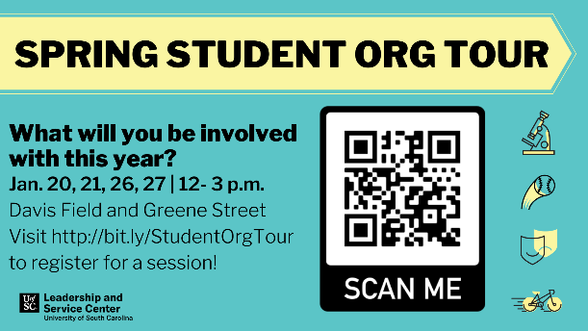

Student Org Activities Post-Thanksgiving
As we wrap up the semester, we just want to give a friendly reminder that student organizations are not to have any activities or events between Dec. 2-14. This is in place to ensure that students are focusing on their finals and academics. If you have questions about this university policy, please let us know.

Changemakers Retreat
Students are chosen to be a part of Changemakers based on their passion for exercising leadership to make positive change on our campus. Selected students will work together to collectively implement a project that will impact the student experience related to student organizations, leadership development, service, or civic engagement.

Students interested in becoming a Changemaker should apply at this link by Dec. 1 at 5 p.m. Selected students will begin their role by participating in a one-day retreat where students will have the opportunity to connect with each other and identify the key project ideas to implement.

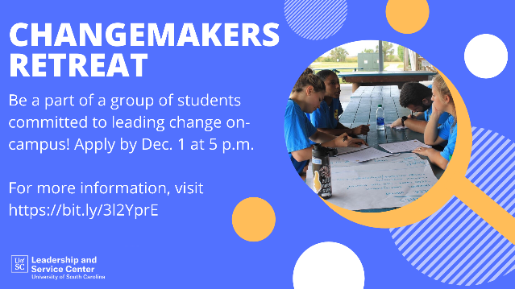

Garnet Gate Roster Update
Verified records of student organization memberships are collected in each student’s My UofSC Experience, a university platform which records the many experiences both for credit and not for credit that students engage in while at UofSC.

In order for your organization members to have their involvement included in My UofSC Experience, it is your responsibility as an organization to verify your roster is up to date for Fall 2020 and that it reflects your active membership. The accuracy and integrity of these student records is essential. Only records of membership that have been verified will be collected in My UofSC Experience.

Click here for a video showing how to complete this process through the manage portal in Garnet Gate.

Funding Requests
We are currently accepting funding applications for Spring events! Student organizations may request funding for programming, virtual conferences, competitions, and tournaments using the Garnet Gate budget request. Organizations are encouraged to work with their Comptrollers as a resource throughout the allocation process. There is still time to plan awesome events for the Spring semester, get your requests in early!

Student Organization Resources
Looking for resources on how to lead your organization? Head over to the LSC’s website to view the Organization Toolbox to get resources on marketing, communication, event planning and more!
Service Saturday
Service Saturday is a monthly service day where volunteers can choose from a range of service sites. Consider organizing a group of members to engage together to further your relationships with each other while engaging with the Columbia community. The first Service Saturday of 2021 will be on Jan. 16, which is the Annual MLK Day of Service. Please register on the Service Saturday website. If you have any questions, contact Megan Michener in the Leadership and Service Center.

